Alphabetical Order
Check List
- Are the first letters the same?

- Are the second letters the same?

- Once you discover the letters that are all the same, mark those letters out.

- Number the words based on the letters that are different. So all the words with A would get a number 1, all the words with B would get a number 2, and so on.
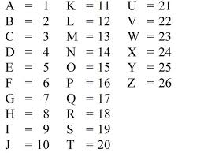

- Based on the numbers, put your words in alphabetical order.

