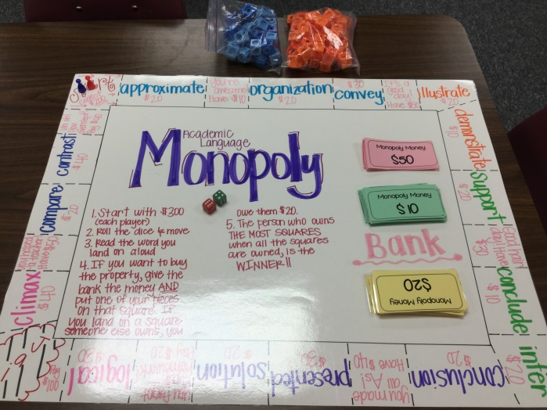
Academic Language Monopoly

- Start with $300 for each player
- Roll the dice and move
- Read the word you land on aloud
- If you want to buy the property, give the bank the price listed in that box AND put one of your pieces on that property
- If you land on a box that someone else owns, you owe them $20
- The winner is determined by who owns the most property. A tie-breaker could be who has the most money

