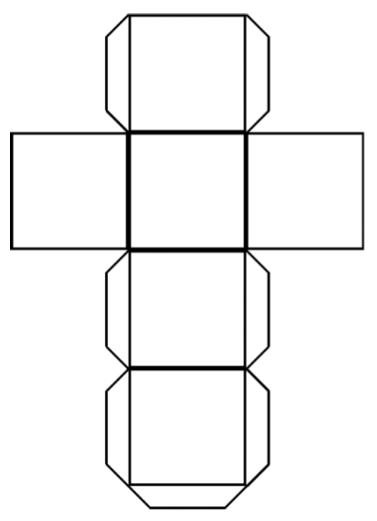

**6. Argue for or against it.**

**5.**

**Apply**

**it.**

**4. Analyze it.**

**3. Associate it.**

**2. Compare it.**

**1. Describe it.**