Sight Word Jenga
- Set up the Jenga stack as the regular game calls for with three blocks one direction followed by three blocks the opposite direction (see picture)

- Before beginning the game, your teacher will let you know if you are playing with the red words or black words.
- Player one draws a block out of the tower. That player must read the word (red or black, depending on which your teacher assigns) correctly in order to keep the block. If they read it incorrectly, they must give that block to the other player.
- Play continues back and forth until the tower falls.
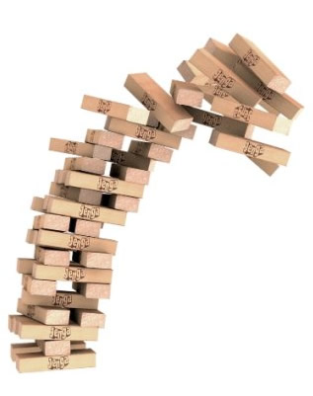
- You want to have the most blocks at the end of the game when the tower falls.

