This text structure tells events that happened and explains reasons why they happened. | This text structure describes events or things in order.
This text structure looks at similarities and differences. | This text structure describes someone or something. It lists details, examples, and descriptions of someone or something.
This text structure explains an issue that needs to be solved and then lists and describes the ideas for solving. | This text structure states something the author thinks or believes in and all of the reasons why they think that way.

Cause-Effect | Chronological/ Sequential Order
Compare-Contrast | Description
Problem-Solution | Position-Support

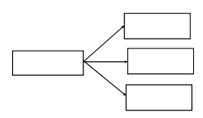 | 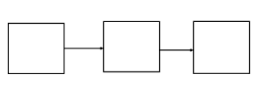
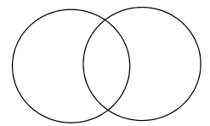 | 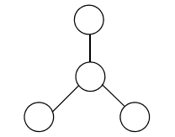
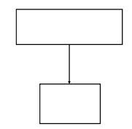 | 